

TPM SM User Guide
Table of Contents
Guide Overview 2
Step 1: Login to MAG 2
Step 2: Access TPM 3
Step 3: Update Cyber Security Section of Self Certification 4
Step 4: Complete the Cybersecurity Compliance Risk Assessment (CCRA) Questionnaire 8
Submitter’s Details Page Guidance 15
Update Completed Form 16
Form Upgrade 16
Form Grouping 17
Business Issue 17
Solution 18
Group Setup 18
View Form Groups 19
Supplier Management Resources 20

Guide Overview
This guide provides instructions to update your organization’s cybersecurity posture within Trading Partner Management (TPM) and Supplier Management (SM), as well as the following organization maintenance processes:
- Performing general organization TPM maintenance. This can be performed when your organization’s status is either Active or Expired.
- Completing the CCRA questionnaire in SM, which is necessary for Lockheed Martin to make risk-based procurement decisions of your company’s products and services.

IMPORTANT: Only the Organization Administrator, having logged in with 2-Factor Authentication (2FA) credentials, can make changes to the company’s TPM profile. For more information on 2FA credentials please visit https://www.myexostar.com/?ht_kb=lockheed-martin#lockheed-martin-accepted-credentials.

It is also important to note, to recertify an organization, there must be at least one (1) active LMP2P user with 2FA credentials (this can be the Organization Administrator) associated with the organization.

Step 1: Login to MAG
To access your TPM profile, you must first login to your Exostar’s Managed Access Gateway (MAG) account. For help resetting your MAG password or any other MAG-related questions, refer to https://www.myexostar.com/?ht_kb=mag.

NOTE: If you are the first user in your organization to access SM, you must accept the standard MAG Usage Service Agreement. If you see Agree to Terms on the Supplier Management tile in your MAG account, click the button and accept the service agreement.

To login:
- Navigate to https://portal.exostar.com. Input your Email Address or User ID. Click Next.
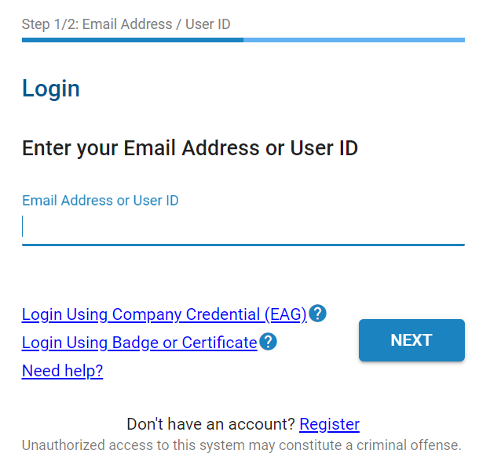

- Input your Password. Click Next to access the MAG Dashboard.
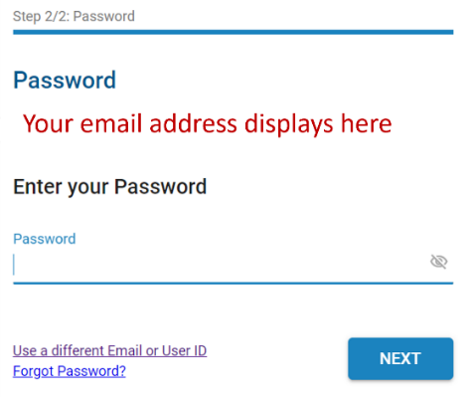

Step 2: Access TPM
Once you successfully login to your MAG account, ensure you authenticate with your credential. You can do this by selecting the Elevate Credential Strength button in the My 2FA Credentials section. The system also prompts for your credential once you select to access TPM.
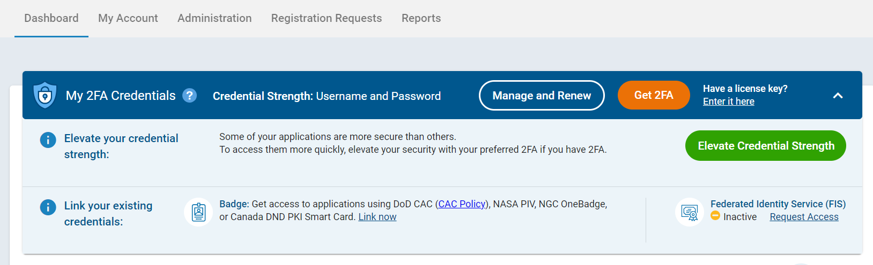
To access TPM:
- From the MAG Dashboard, select the My Account tab.
- Select the View Organization Details sub-tab.
- Click the View in Trading Partner Management (TPM) link.
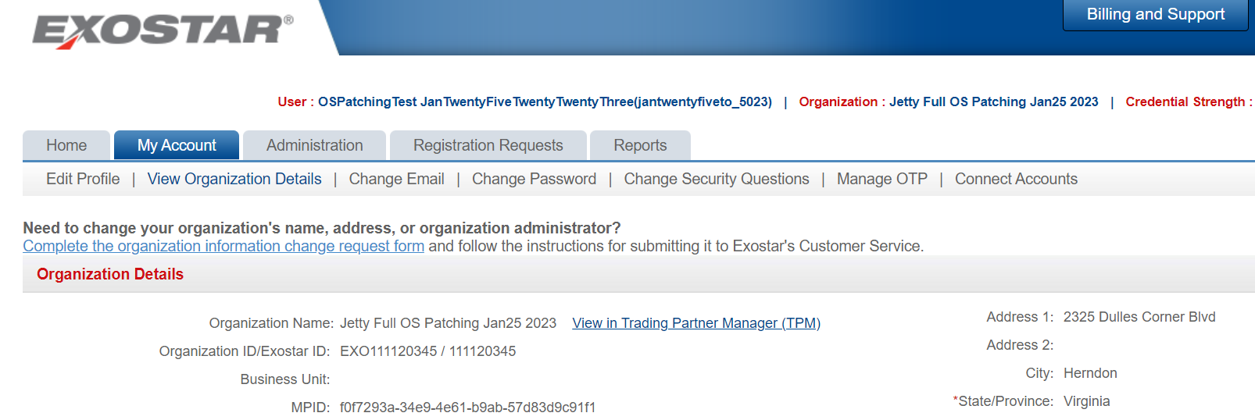

- The following screen displays. Review the notice. Click the Continue button to access the Organization’s profile.
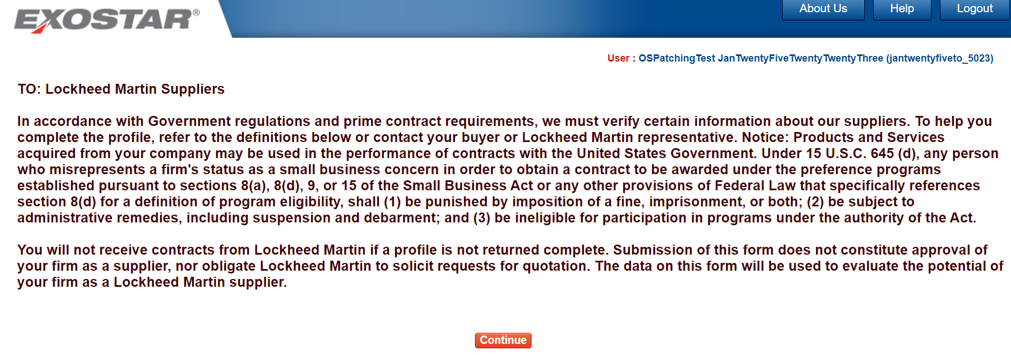

Step 3: Update Cyber Security Section of Self Certification
The CCRA Questionnaire provides questions related to the applicability of cyber Defense Federal Acquisition Regulation Supplement (DFARS) requirement and the handling of Sensitive Information, which is required annually. To update the Cyber Security section:
- Select Self-Certification from the left-hand menu.
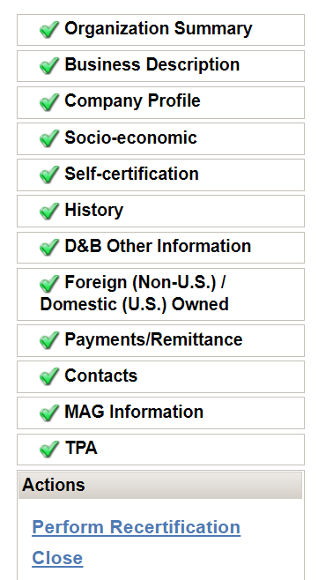

- Scroll down to the Cyber Security section. Review the information provided.
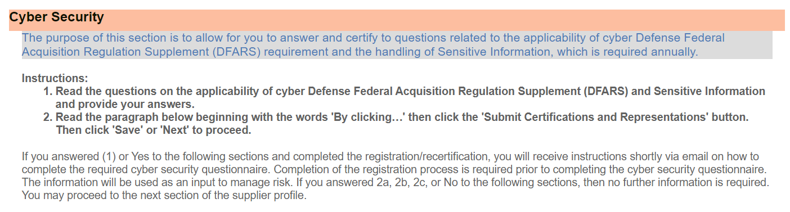

- Under the Applicability of Cyber DFARS and NIST SP 800-171 section, review the question and select the applicable radio button for the answer.

IMPORTANT: Carefully review this section and select the appropriate answer.

If you select (1) Seller asserts that DFARS 252.204-7012 applies. (By so asserting, Seller is required to complete the Exostar Cybersecurity Compliance and Risk Assessment (CCRA) questionnaire and confirm assessment score in US DoD’s Supplier Performance Risk System (SPRS).

Selecting options 2(a), 2(b), or (2c), asserting that DFARS 252.204-7012 and Covered Defense Information / Controlled Unclassified Information does not apply, will not prompt you to complete the CCRA questionnaire.
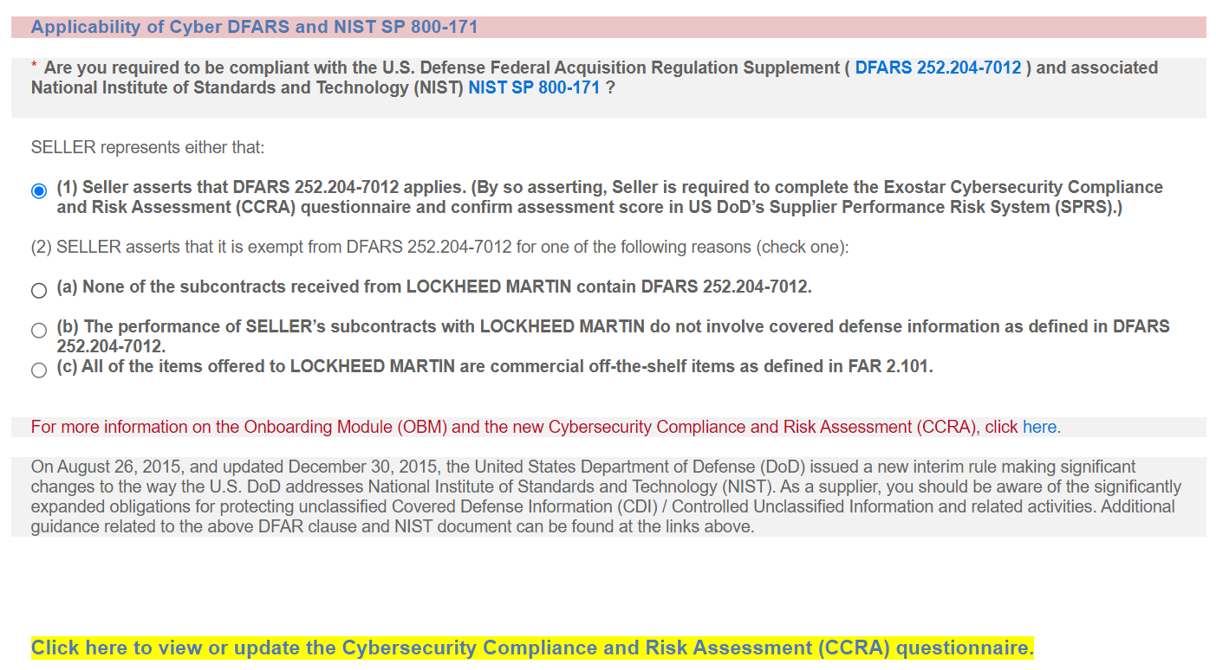

- Under the Handling Sensitive Information section, the question will automatically be set to Yes if the Applicability of Cyber DFARS and NIST SP 800-171 question is (1). Otherwise, you need to assert whether you are receiving any Sensitive Information from Lockheed Martin.
NOTE: Once you answer both questions, you can begin the Cybersecurity Compliance Risk Assessment (CCRA) Questionnaire by selecting the highlighted link under either section.
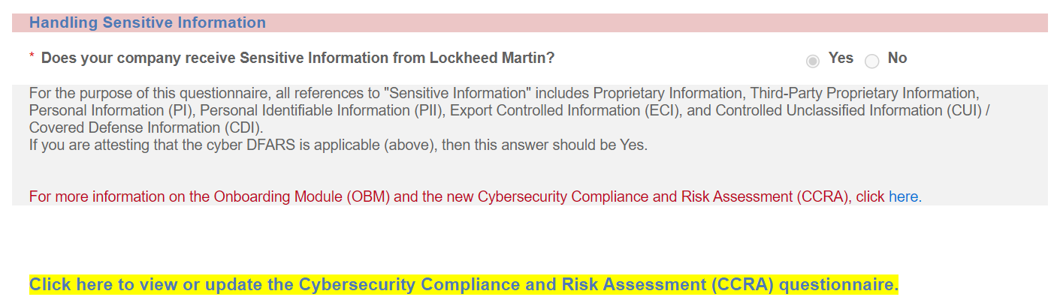

IMPORTANT! The verbiage in red provides a help link to learn more about the application and CCRA. Please note, this verbiage still references Onboarding Module (OBM), which has been rebranded to Supplier Management (SM). This will be updated in TPM eventually.

IMPORTANT! If you answer (1) on the DFARS applicability section or Yes to the handling Sensitive Information question, the CCRA form is automatically assigned to you.

- Once all required sections are complete, click Submit Certifications and Representations.
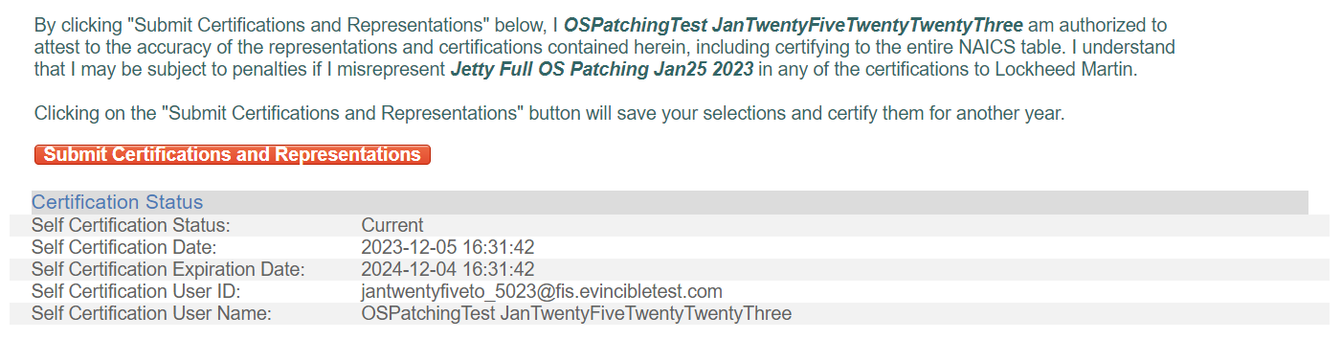

NOTE: A confirmation message displays, and self-certification dates and user information displays below the message. The completed certification and representation are valid for one year from submission. The system sends your Organization Administrators annual expiration warning emails, starting 60 days in advance of the calculated expiration date. You can perform the certification and representation process at any time during the year.

Step 4: Complete the Cybersecurity Compliance Risk Assessment (CCRA) Questionnaire
Once you access SM, the CCRA Questionnaire displays in the Pending Forms tab of the dashboard and displays important details for the form. To access and complete the CCRA Questionnaire:
- Select the highlighted Click here to view or update the Cybersecurity Compliance and Risk Assessment (CCRA) questionnaire link to open the Supplier Management. The link also displays under the Handling Sensitive Information section.

NOTE: SM can also be accessed through the Managed Access Gateway (MAG) dashboard via the SM tile. Click Launch.
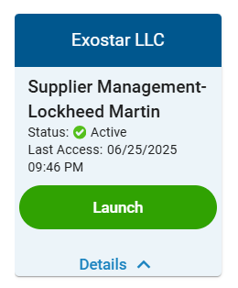

IMPORTANT! The verbiage in red provides a help link to learn more about the application and CCRA. Please note, this verbiage still references Onboarding Module (OBM), which has been rebranded to Supplier Management (SM). This will be updated in TPM eventually.

- Locate the CCRA Questionnaire in the Pending Forms tab from the SM Dashboard.
NOTES:
- Anyone with SM access and that is assigned to the form, can update, or complete the questionnaire. The Assigned To section indicates the current user assigned to the form. Only one person can be assigned to a form at any given time.
- You can initiate work on the form only when the Request Status is at 40%.
IMPORTANT! If the Request Status is at 20%, it indicates either the form is not provisioned, or the invitee accepting the invitation and the designated organization administrator are two different users. In such cases, the designated organization administrator needs to re-assign the form to themselves. See Step 3 below.
- The Form Progress for a new form starts at 0% and the revision is 0.1 for a form that has never been started. In the provided screenshot, the user has already submitted the form once and is now renewing it for the second time. Therefore, the Form Progress is at 100%, and the Revision is 1.1.
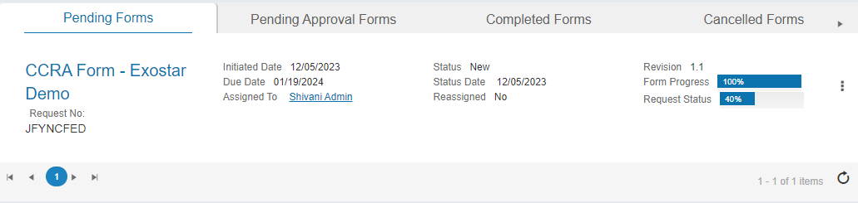

- Select the three dots action button located to the right. Select Edit from the menu.
NOTE: You can also reassign the form by selecting the three dots action button.
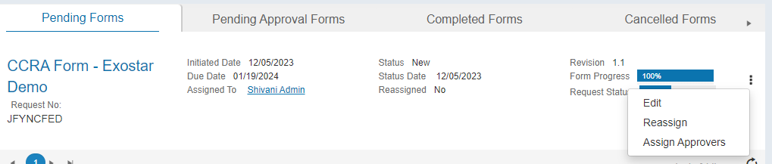

NOTE: Alternatively, select the hyperlinked form name and choose Edit Form on the Form Details page. You also have the option to download the latest Excel file, accessible in the Offline Form section. This option requires you to complete the form offline and upload the CSV. Please review the instructions provided on the Introduction worksheet of the file.
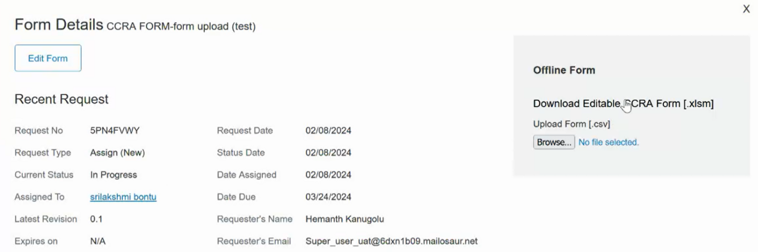

IMPORTANT! If the Edit button is not displayed, the form is not currently assigned to you. Use the Reassign option to assign the form to the correct user. Only one person can be assigned to a form at any given time.

- Review the Introduction page. Click Next.
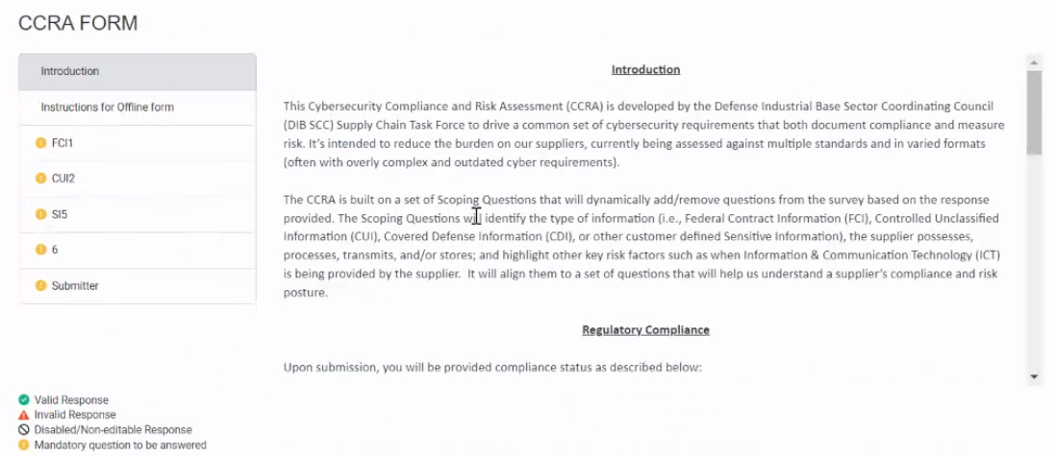

NOTE: Once the supplier begins working on the form, they have the flexibility to save the form and exit at any point. All entered information will be saved during this process.
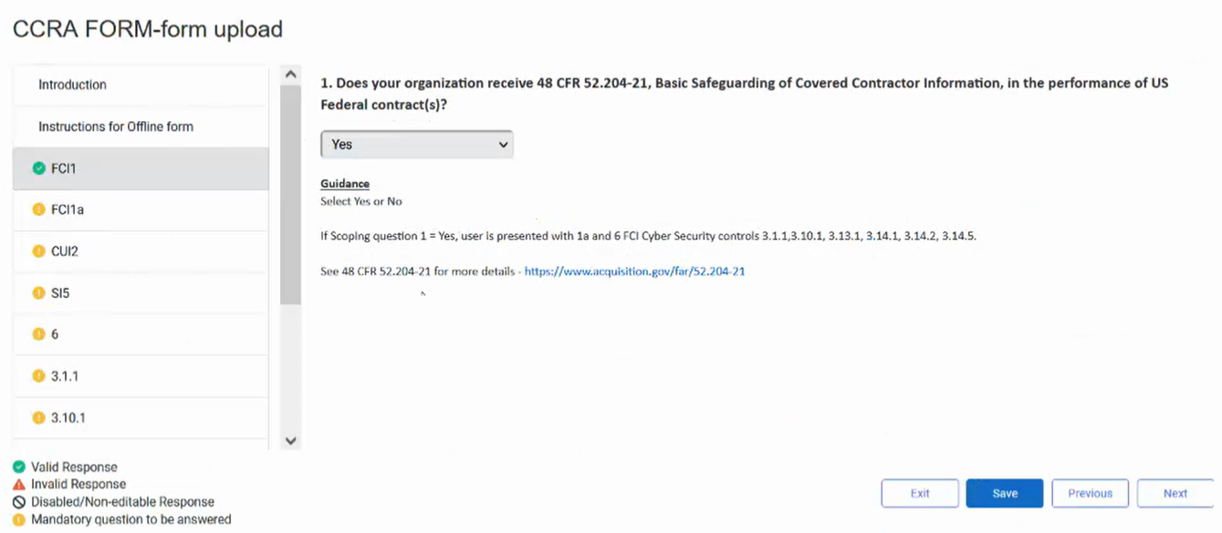

- Complete all questions in the form.
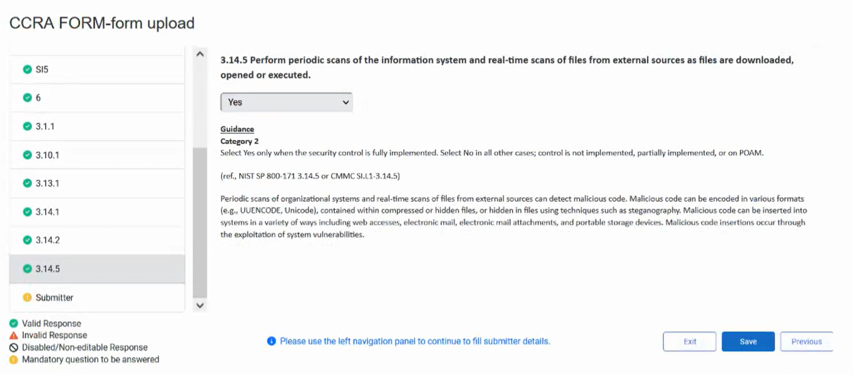

- Click the Save button.

IMPORTANT! Users must ensure they click the Save button prior to clicking the SUBMIT button at the end of the survey to complete the questionnaire. The Save button does not submit the survey for scoring or updates. The Submit button remains greyed out until ALL questions are answered and the form has been saved.
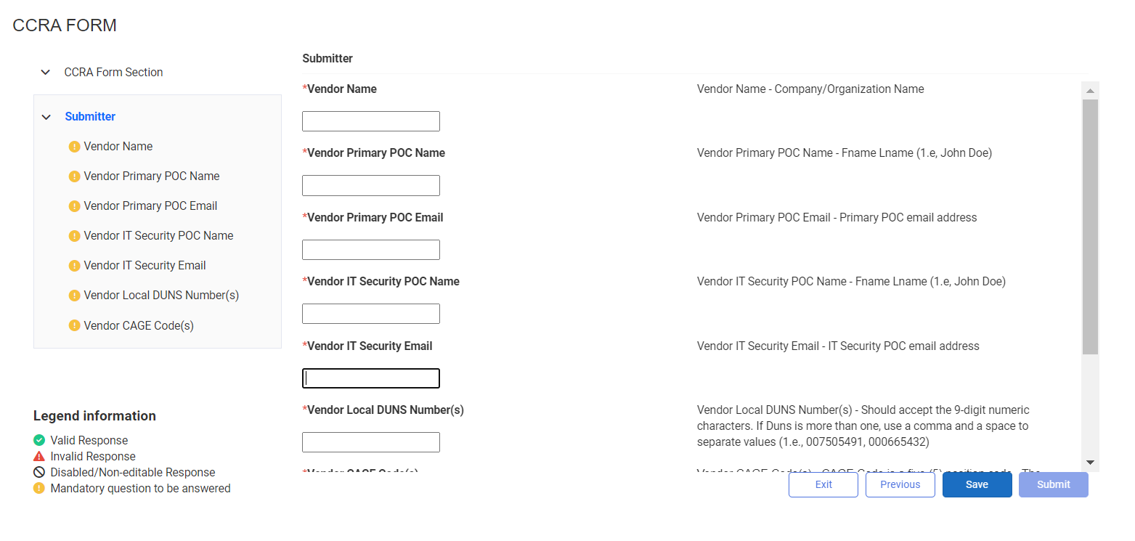

- Click OK to confirm save.
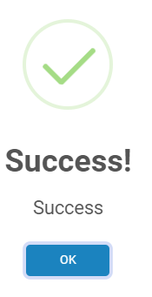

- Click the Submit button.
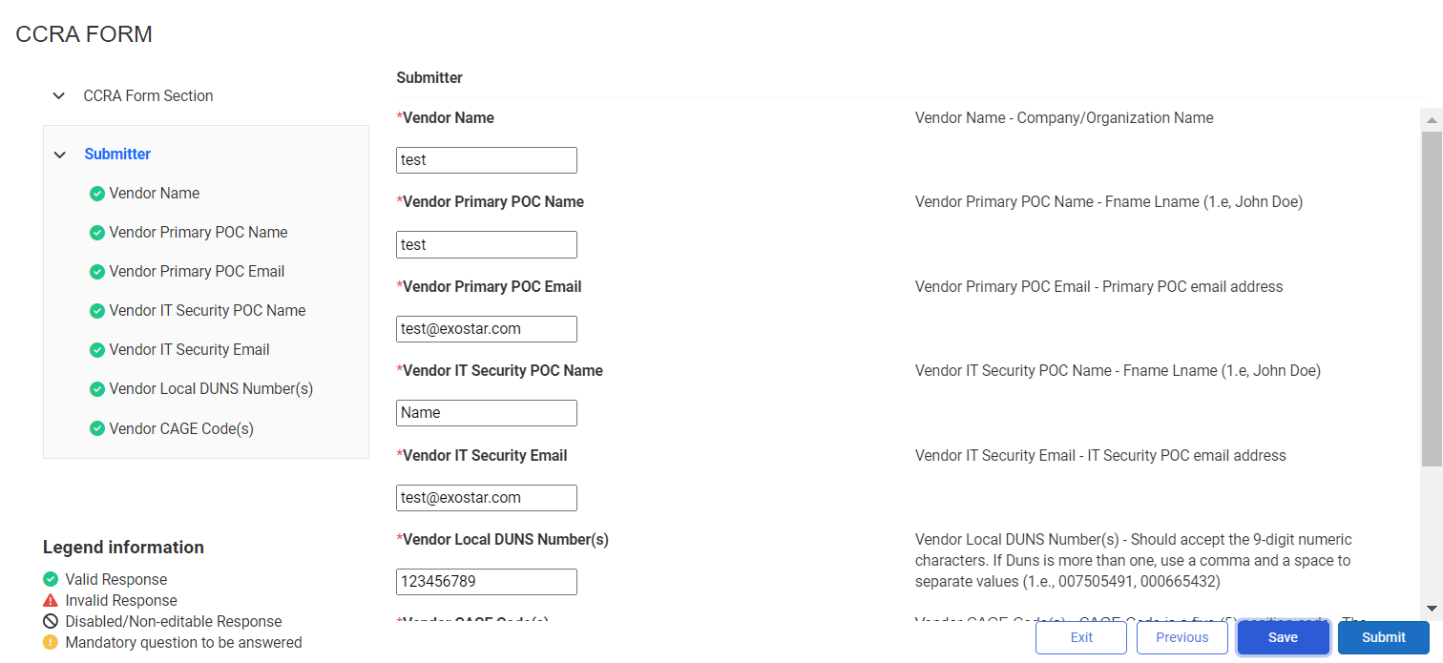

NOTE: Please see the Submitter’s Page Detail Guidance section below for guidance on completing these fields.

- Click OK to confirm submission.
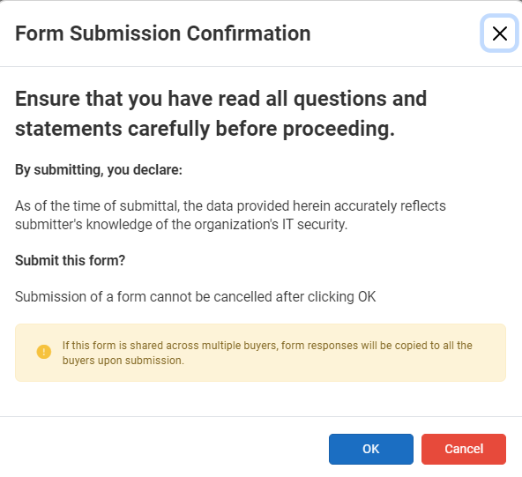

Please note as you progress through the form request, you will see the following Request Status percentages:
- Pending Provisioning: Request Status 20%
- Provisioned: Request Status 40%
- First Time Access: Request Status 60%
- Form Started: Request Status 80%

NOTES:
- Once the user submits the form, the form displays under the Completed Forms tab.
- The score summary details are displayed on the bottom right of the Forms Details page.
- Recent Request will be updated to include expiration date of the form.
- Revision History will display the latest revision. Additionally, you will have the ability to download all the revisions. The answers display along the right-hand side of the PDF.
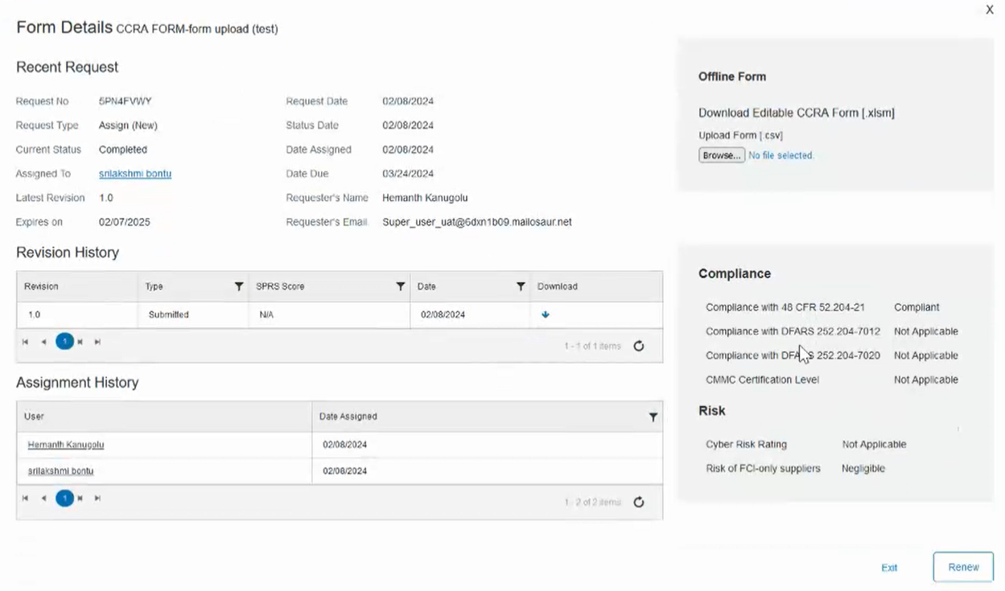

Submitter’s Details Page Guidance
Field Name | Guidance
Vendor Name | Company/Organization Name
Vendor Primary POC Name | First Name Last Name (i.e., John Doe)
Vendor Primary POC Email | Primary POC email address
Vendor IT Security POC Name | First Name Last Name (i.e., John Doe)
Vendor IT Security POC Email | IT Security POC email address
Vendor Local DUNS Number(s) | If more than one, use a comma and a space to separate values (i.e., 007505491, 000665432)
Vendor CAGE Code(s) | If more than one, use a comma and a space to separate values (i.e., 3T456, 56789)
If the response on this form is applicable to more than one of your organization's business units/divisions, provide all the Local DUNS Number and CAGE Codes that applies. You'll be able to export a single form for multiple DUNS/CAGE Code

Update Completed Form
To update the submitted form, you must renew the form. To do so:
- Navigate to the Completed Forms tab.
- Click Renew from the action button or from the Forms Details pages.
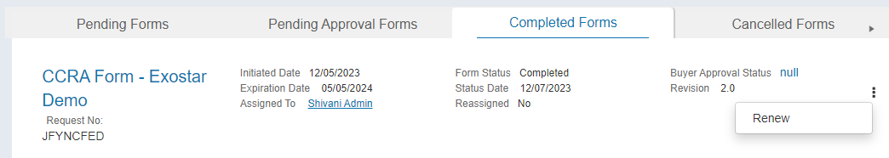

NOTE: This action will move the form back to the Pending Forms tab.
- Select to Edit the form and complete the steps as outlined above.

Form Upgrade
It is possible for your partner to upgrade a form from its previous version (i.e., add or remove questions). Once the form has been upgraded, you must edit the form and complete the upgraded questions. To upgrade a form:
- Navigate to the desired Form Details page. Click the Edit Form button.

- An upgrade notification displays. Click the Next button.
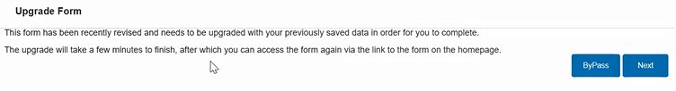

NOTE: The system can take up to five minutes to upgrade the form. You do not have to wait for form to upgrade and can Exit and come back later. If you do wait, a confirmation screen displays.
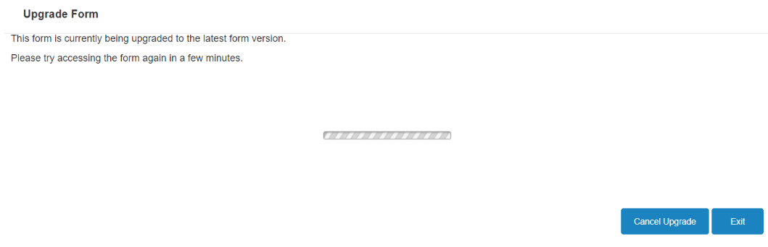

- If you wait for the form to upgrade, click Continue from the confirmation screen to begin editing the upgraded form.
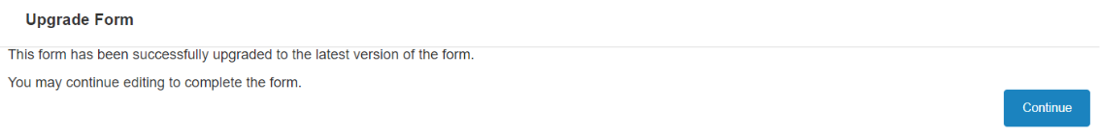

- If you do not wait for the form to upgrade, you can Exit and come back later. Navigate to the Form Details page and click the Edit Form button to edit the upgraded form. Complete the form as you would normally.

Form Grouping
Form Grouping is used to share a completed form your organization filled out with your compatriot business units. The sections below provide step-by-step instructions on how to share your group form.

Business Issue
Company XYZ is composed of several subsidiary companies and/or business units (BU), each one of which is a Supplier to one or several Exostar Buyer organizations. Each of the subsidiaries is being asked to complete forms from one or more Buyer organizations. This results in requesting many of the subsidiaries to complete the same form. The security policies and infrastructure of the subsidiaries of Supplier XYZ are managed and controlled by a single shared service, an organizational unit located within one of the registered XYZ companies/subsidiaries. That unit can answer the form on behalf of many of the XYZ subsidiaries. This unit would like to answer the form once for all subsidiaries covered by its security program.

Solution
Exostar has the capability to create a Form Group of companies/businesses where one of the businesses can represent the group when completing forms. The XYZ business needs to nominate one of the business units as the source to represent the group. That business completes the form on behalf of the group (Destinations), and the results are provided to Buyers XYZ subsidiaries chose to share the results. In this way, the form is under the control of a single subsidiary or business unit within the group, but shared by any of the others with whatever Buyers they wish.

Destination organizations can share the group form with individual Buyers just like any other normal assigned form with two major exceptions:
- The form is locked and only the Source Organization can edit it. All further edits are reflected in the destination form in real-time.
- When a form is submitted, the scoring of the shared form applies to the one associated with Destination Organization as well.

Group Setup
Company XYZ needs to do the following to setup the group within Exostar:
- Create a support case via the Support page and describe the case as Create a Form Group in SM.
- Provide the Form Grouping Submission Form that identifies:
  - The source business unit by its Exostar ID, DUNS ID, full address, and email address of the responsible person who will handle the security form.
  - The destinations or business units within the group by Exostar ID, DUNS ID, and address for each.
  - Which form is to be shared with the Destinations.

- Exostar contacts each destination business unit to confirm they will be added to the new group.
- Exostar creates the group within the organization data and the form from the source will be available for the destinations.

NOTES:
- The source organization must submit the form for the responses to be duplicated onto their respective destination organization forms.
- If a new supplier is added to the existing Form group, the Source organization must resubmit (renew) the form for the responses to be duplicated onto their respective destination organization forms.

View Form Groups
To view form groups:
- Source Organization, click the group icon next to the form name.
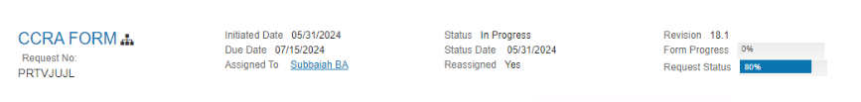

- Review the table providing information on the source and destination organizations. Click the Close button when finished.
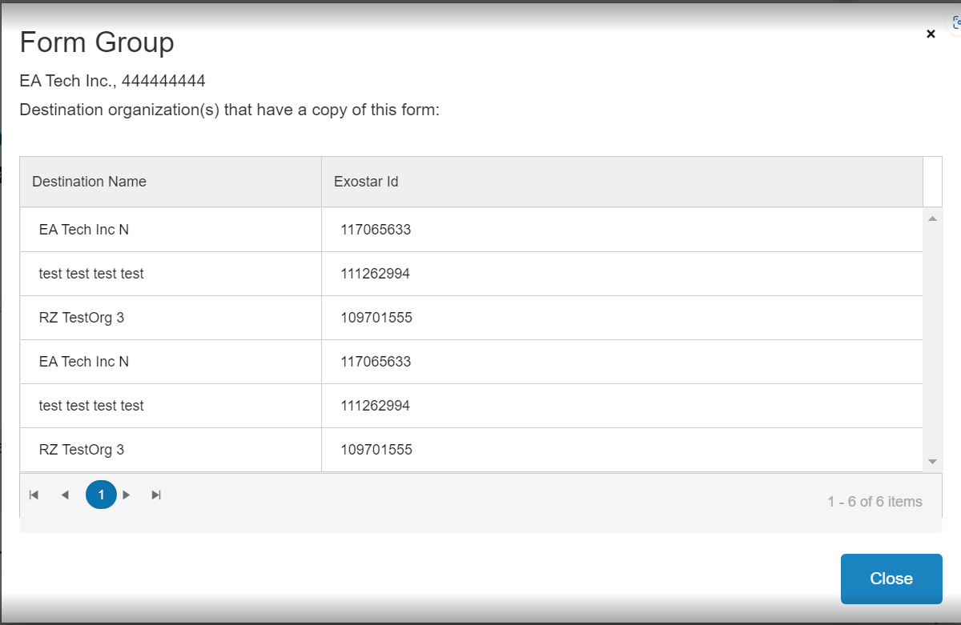

The destination organizations will display messaging on the Form Details page. The message will read: This form is being shared by the following organization ORGNAME. You do not have permissions to edit this form.
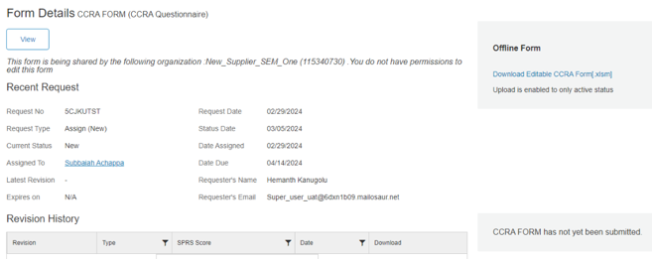

Supplier Management Resources
The following SM resources are located on Exostar’s Self-Help portal:
- Supplier Management: This landing page provides an application overview, roles and responsibilities, as well as additional resources links.
- Supplier Management Get Started: This page provides access instructions.
- Supplier Management Training Resources: This page provides downloadable guides for Buyers, Suppliers, and Reporting.

