



Last Updated 8/12/2015
Last Reviewed 5/24/2022

LM Procure to Pay Quick Reference Guide For Suppliers

View Changed Purchase Orders

Lockheed Martin Procure to Pay Revised August 2015

Procedure

This quick reference guide displays the procedure to view changed purchase orders

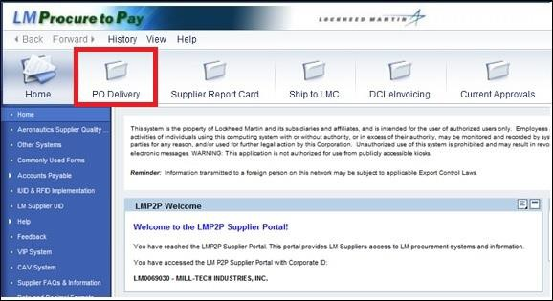

Step | Action
1. | 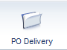  Click the PO Delivery tab.

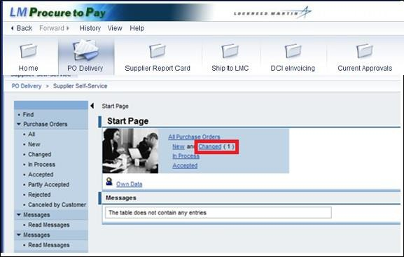

Step | Action
2. | Click the Changed link.

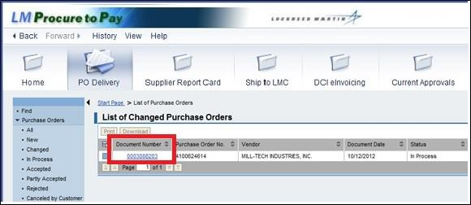

Step | Action
3. | The changed purchase orders display with entries for document number, purchase order number, vendor, status and more.
4. | 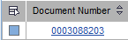  Click on the document number to select the purchase order.

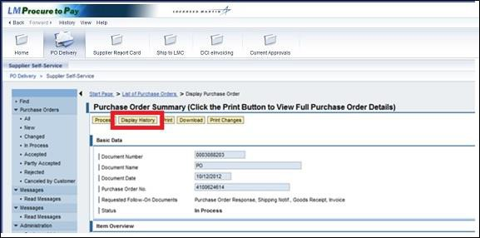

Step | Action
5. | To examine the changes made to the purchase order, click the Display History  button.

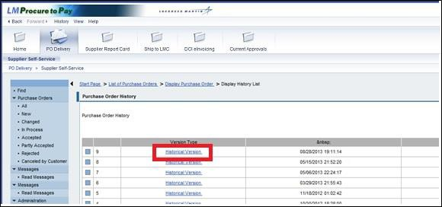

Step | Action
6. | Click the Historical Version link.

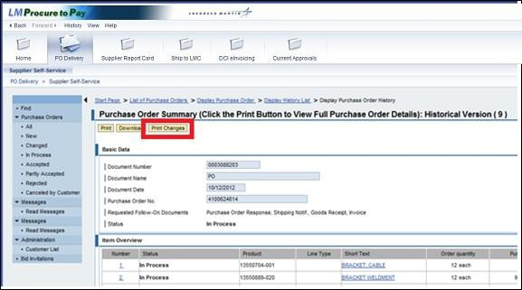

Step | Action
7. | Click the Print Changes button.

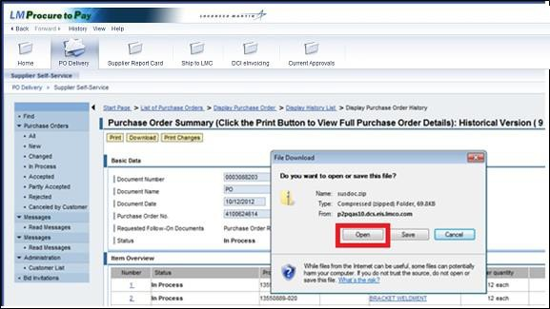

Step | Action
8. | Click the Open button.

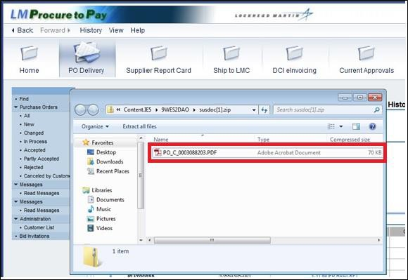

Step | Action
9. | Double-click the .pdf file to open.

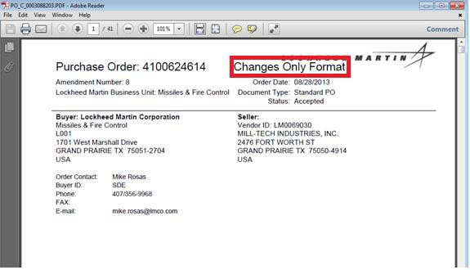

Step | Action
10. | This file displays the Changes Only Format for the purchase order.

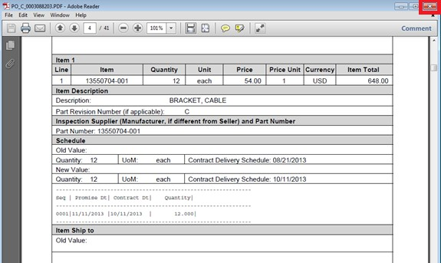

Step | Action
11. | Scroll down the page to see the changes listed on each line item..
12. | To return to the previous screen, click the Close button.

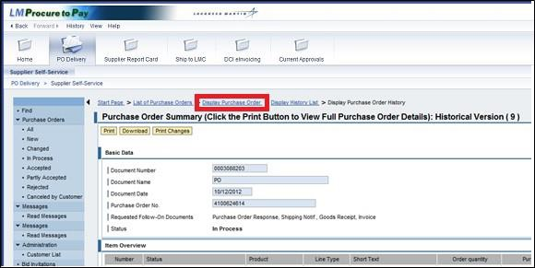

Step | Action
13. | To begin processing the changed schedule agreement, click the Display Purchase Order link to return to the Purchase Order Summary screen.

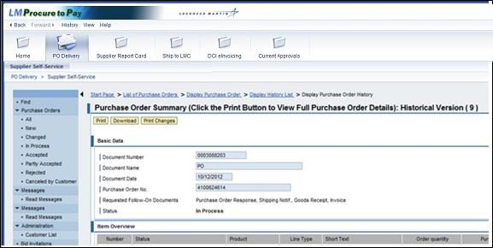

Step | Action
14. | If an amendment is processed for a PO and the supplier subsequently rejects the amended items, this results in a situation where some line items are Accepted and some Rejected. These PO's are classified under the Partly Accepted status.
15. | You have successfully completed the procedure to view changed purchase orders.

